Part A: UDP
UDP Traffic screenshot
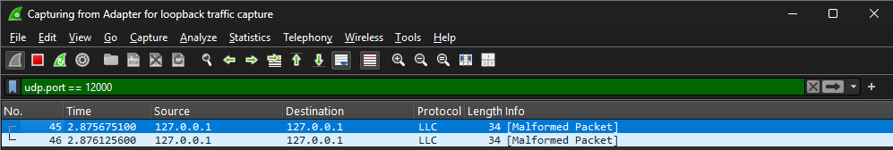
Source: what address the packet originated from (localhost or 127.0.0.1)
Destination: what address the packet is going to (localhost or 127.0.0.1)
Protocol: what is the highest-level protocol used, shows LLC because of the port being used (12000)
Length: length of the message in bits
Message flow
- Client (127.0.0.1) in packet 45 sent ‘hi’ to server (127.0.0.1)
- Server (127.0.0.1) in packet 46 sent ‘HI’ to client (127.0.0.1)

Part B: TCP
TCP Traffic screenshot
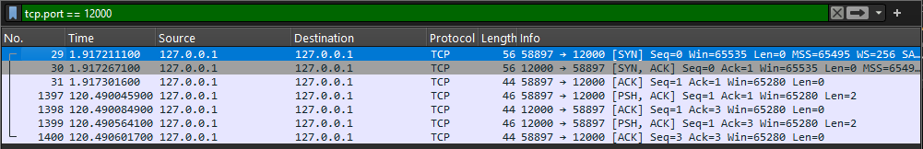
Source: what address the packet originated from (localhost or 127.0.0.1)
Destination: what address the packet is going to (localhost or 127.0.0.1)
Protocol: what is the highest-level protocol used, shows TCP
Length: length of the message in bits
Message flow
- Packet 29: client sends SYN to server to establish connection
- Packet 30: sever sends SYN ACK to client to accept connection
- Packet 31: client sends ACK to server to confirm connection
- Packet 1397: client sends PSH ACK with ‘hi’ to server
- Packet 1398: server sends ACK to client to confirm message was received
- Packet 1399: server sends PSH ACK with ‘HI’ to client
- Packet 1400: client sends ACK to server to confirm message was received

Part C: Reflection
Explanation of client interaction
- UDP just sends messages between the client and server, no connection between them
- TCP creates a connection between the client and server with a three-way handshake, then sends the messages between the two
How do UDP and TCP differ in socket creation and setup
- UDP uses SOCK_DGRAM and just uses bind()
- TCP uses SOCK_STREAM and uses bind(), listen(), and accept() for the connection
How do they handle message exchange and delivery
- UDP uses sendto and recvfrom
- TCP uses send and recv in a stream
What debugging or testing challenges did you encounter
- I used the ‘exit’ case for both, and this was the toughest part to implement as there were times where it did not do what I intended for it to do
What are the trade-offs between using TCP and UDP
- UDP is more lightweight but does not guarantee delivery of messages
- TCP is heavier but provides a secure connection and data stream between the two, which guarantees delivery
What basic security risks are present in your implementation
- There is no authentication so anyone on my computer can connect
- The exit case closes both the client side and server side processes
- No encryption so anyone can see the message contents
How might you begin to address them in Phase 2
- Implement some sort of password or authentication for the connection rather than allowing a connection once the client and server are opened
- Edit the code so that the exit case only closes the client and not the server
- Use some sort of encryption to hide the message contents when being sent over from one process to the other

